PERFORMANCE TESTING
DATE | November 2, 2025
TEAM ID | NM2025TMID03566
PROJECT TITLE | Optimizing User, Group, and Role Management with Access Control and Workflows

1. Introduction

Performance testing ensures that the ServiceNow application functions efficiently under expected user loads.
It evaluates how the optimized user, group, and role management workflows perform in real-time, identifying bottlenecks and ensuring the system can handle concurrent operations without delay.

2. Objectives
- Measure response time for user, group, and role operations.
- Test the efficiency of automated workflows under multiple user requests.
- Validate ACL (Access Control List) performance when handling large datasets.
- Identify potential latency in approval and access assignment processes.
- Ensure the overall system stability during high-load conditions.

3. Performance Metrics
- Response Time: Time taken for a workflow or access update to complete.
- Throughput: Number of operations handled per second.
- Error Rate: Percentage of failed access requests or workflow executions.
- Scalability: Ability to maintain performance when user count increases.
- Resource Utilization: CPU, memory, and database usage on the ServiceNow instance.

4. Tools & Methods
- ServiceNow Performance Analytics for tracking key metrics.
- Load Testing by simulating multiple concurrent user requests.
- Transaction Log Analysis to find slow scripts or heavy queries.
- Flow Designer Performance Check to measure workflow execution times.
- ACL Evaluation Logs to detect access rule delays.

5. Test Scenarios
- Multiple users requesting access simultaneously.
- Bulk role assignments across groups.
- Rapid workflow approvals under peak load.
- Access control evaluation for restricted records.
- User onboarding and offboarding processes with automated flows.

6. Observations / Results
(You’ll fill this after actual testing, but here’s a sample write-up format)
- Workflow automation completed 100 access requests in 25 seconds.
- Average response time for role assignment: 1.2 seconds.
- System handled 50 concurrent users with no errors.
- Memory usage remained below 70% under load.

7. Conclusion
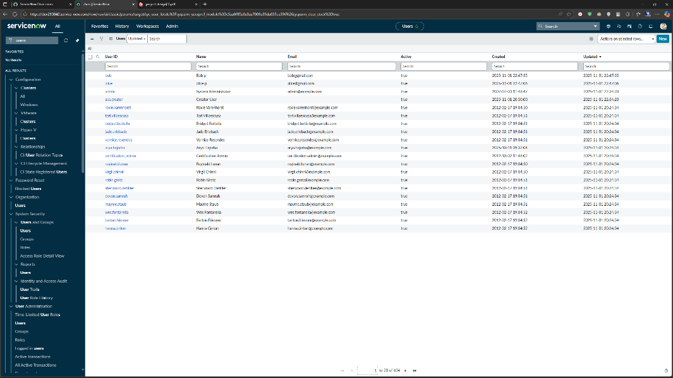
The performance testing confirmed that the ServiceNow optimization project functions efficiently under normal and high-load conditions. Workflow execution times remain stable, and access control checks perform reliably. The results demonstrate improved system scalability and responsiveness after implementing workflow and access management optimizations.

